Assginment-3.2

**AI Assisted Coding**

Name : Radha Krishna Jagarlapudi Batch No : 3G

HT No : 2303A52055

Task Description-1

* **Progressive Prompting for Calculator Design: Ask the AI to design a simple calculator**

program by initially providing only the function name. Gradually enhance the prompt by

adding comments and usage examples. Expected Output-1

* **Comparison showing improvement in AI-generated calculator logic and structure. Code:**

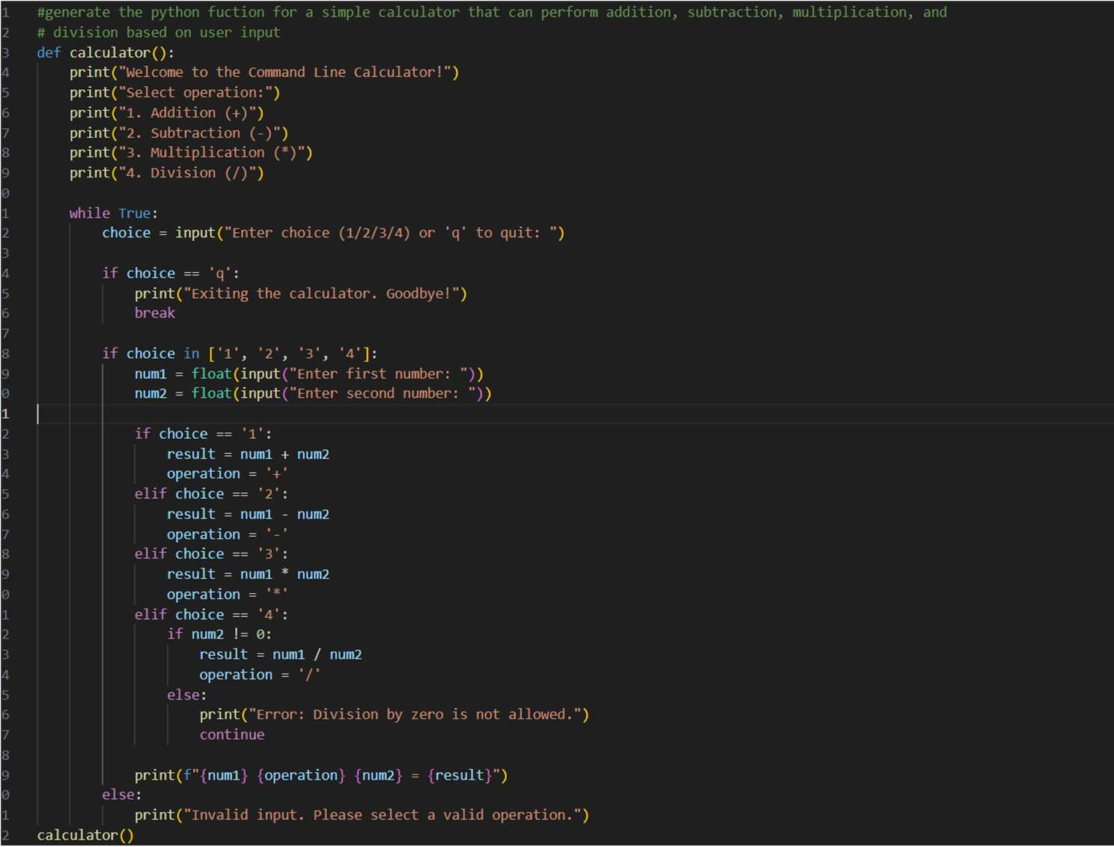

Output:

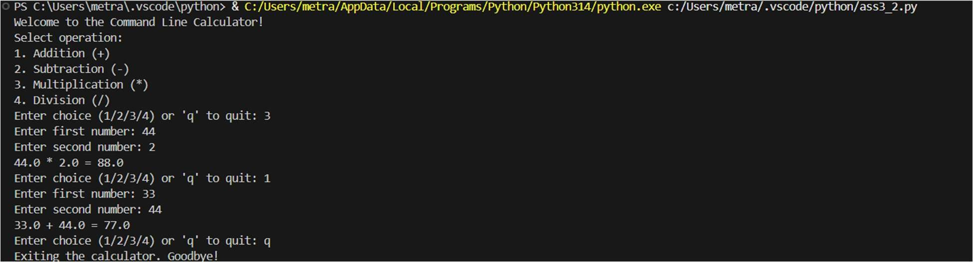

Explaination:

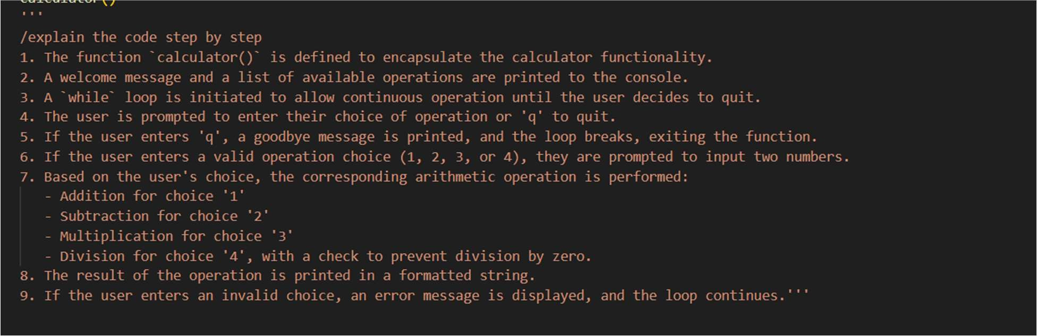

Task Description-2

* **Refining Prompts for Sorting Logic: Start with a vague prompt for sorting student marks,**

then refine it to clearly specify sorting order and constraints. Expected Output-2

* **AI-generated sorting function evolves from ambiguous logic to an accurate and efficient**

Implementation Code:

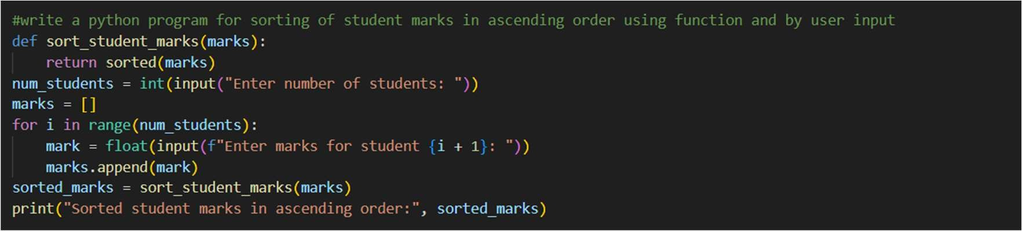

Output:

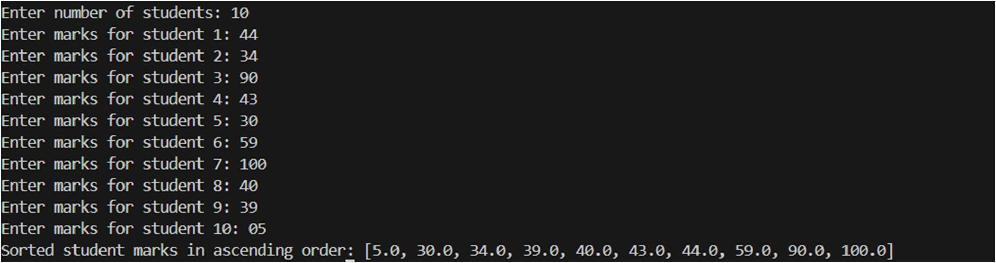

Explaination:

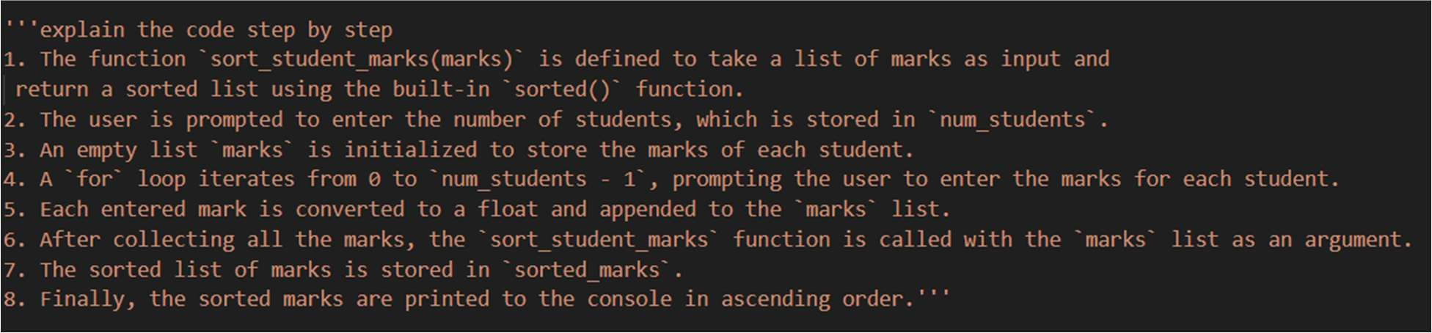

Task Description-3

* **Few-Shot Prompting for Prime Number Validation: Provide multiple input-output**

examples for a function that checks whether a number is prime. Observe how few- shot

prompting improves correctness. Expected Output-3

* **Improved prime-checking function with better edge-case handling. Code:**

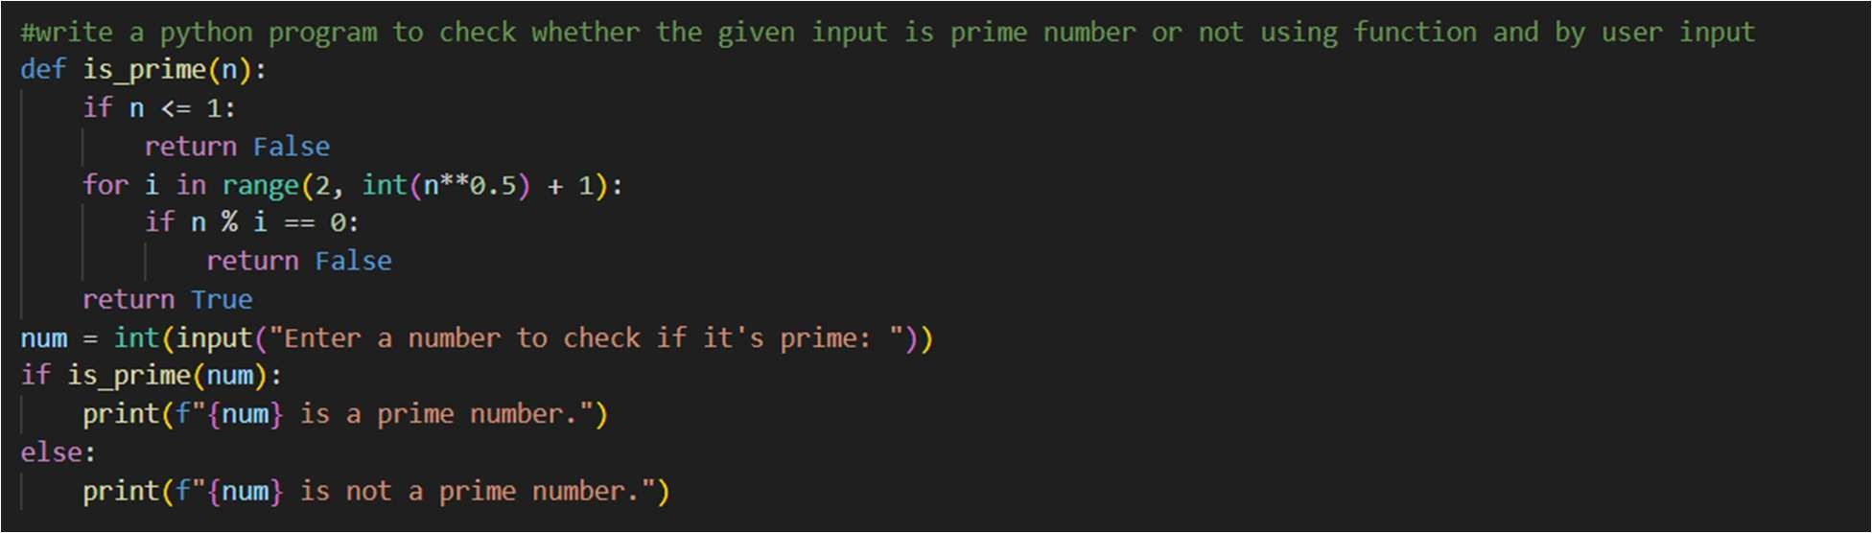

Output:

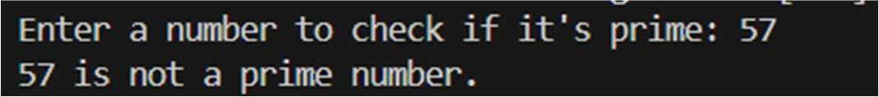

Explaination:

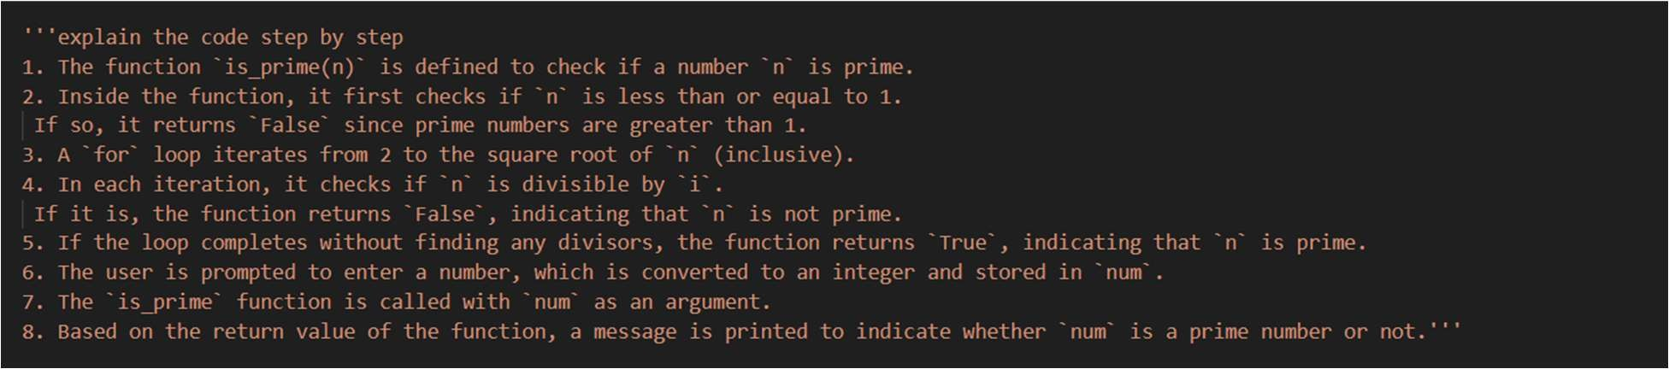

Task Description-4

* **Prompt-Guided UI Design for Student Grading System: Create a user interface for a**

student grading system that calculates total marks, percentage, and grade based on user

input.

Expected Output-4

* **Well-structured UI code with accurate calculations and clear output display. Code:**

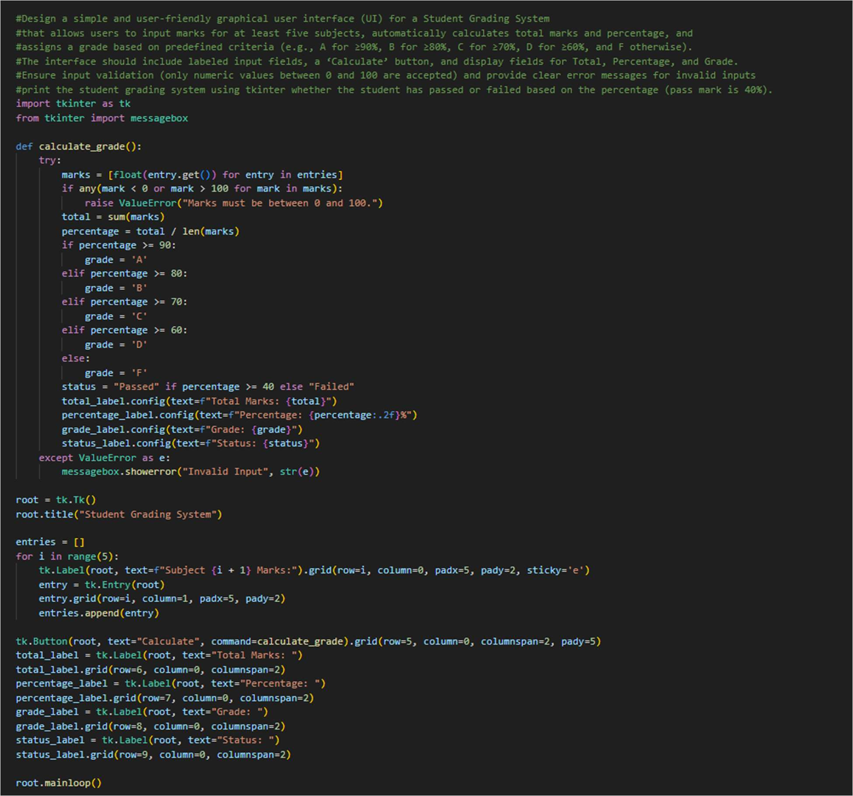

Output:

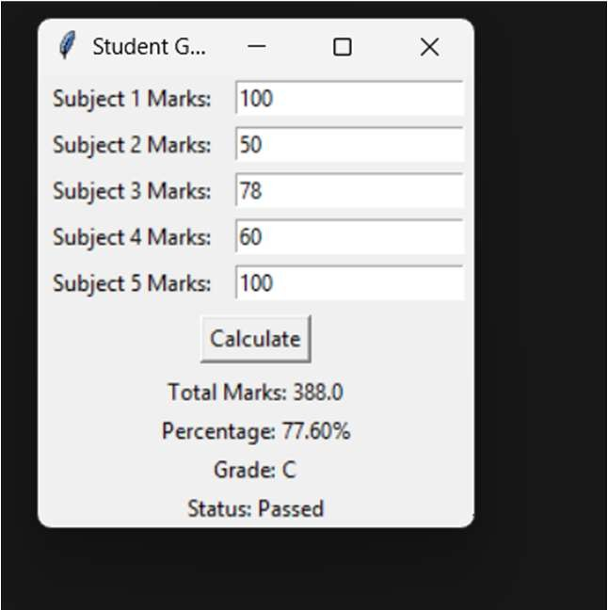

Explaination:

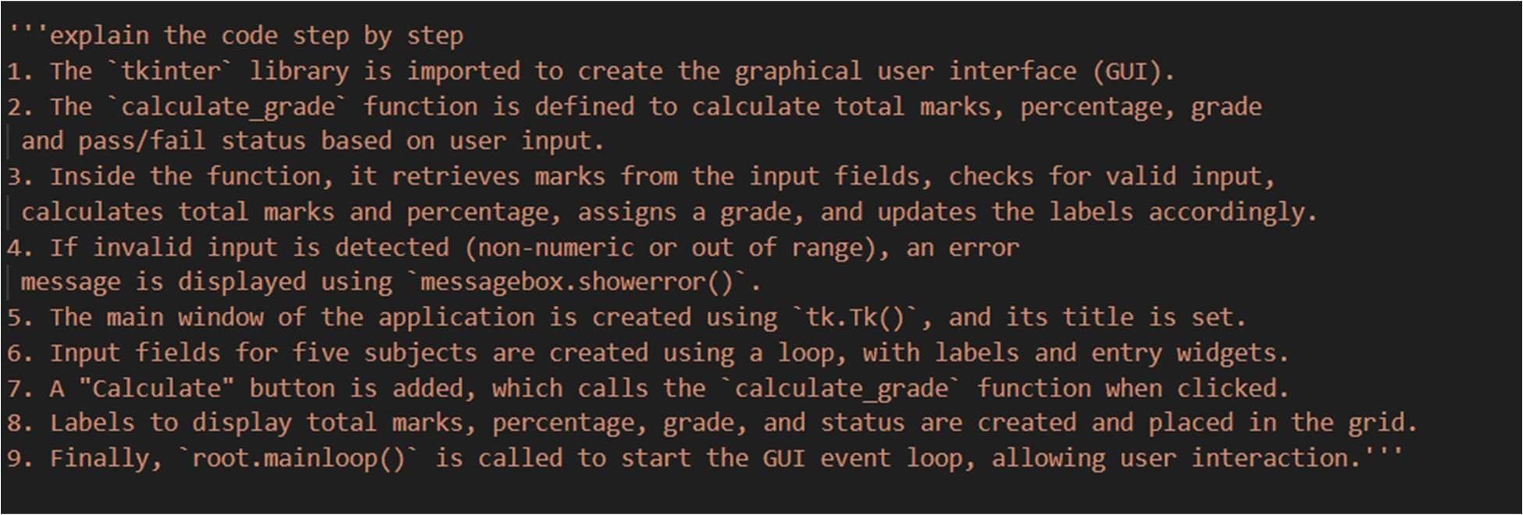

Task Description-5

* **Analyzing Prompt Specificity in Unit Conversion Functions: Improving a Unit Conversion Function (Kilometers to Miles and Miles to Kilometers) Using Clear Instructions.**

Expected Output-5

* **Analysis of code quality and accuracy differences across multiple prompt variations. Code:**

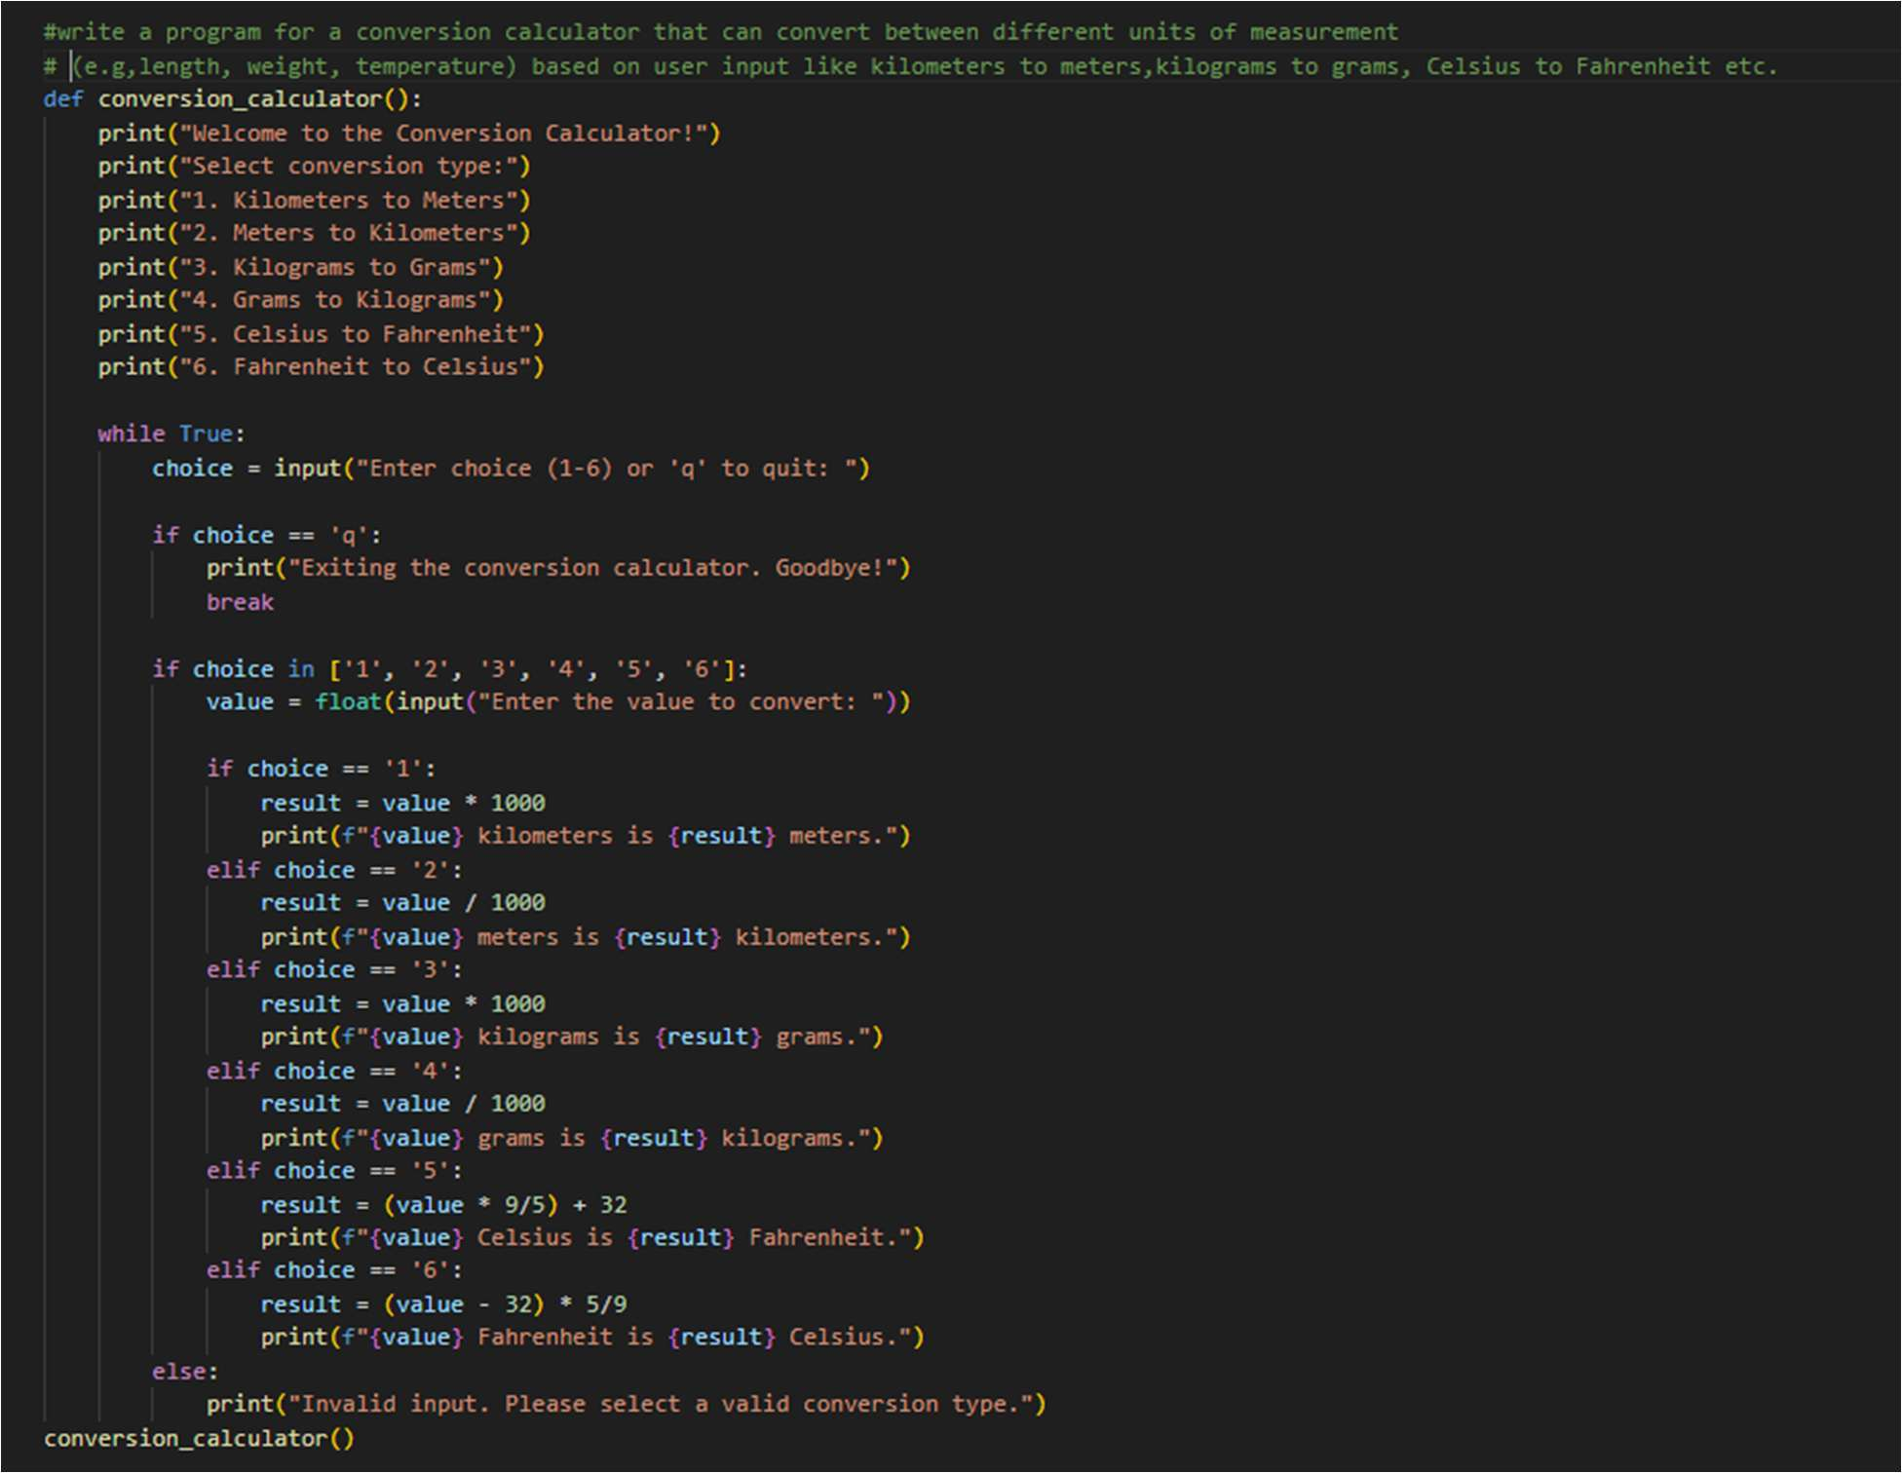

Output:

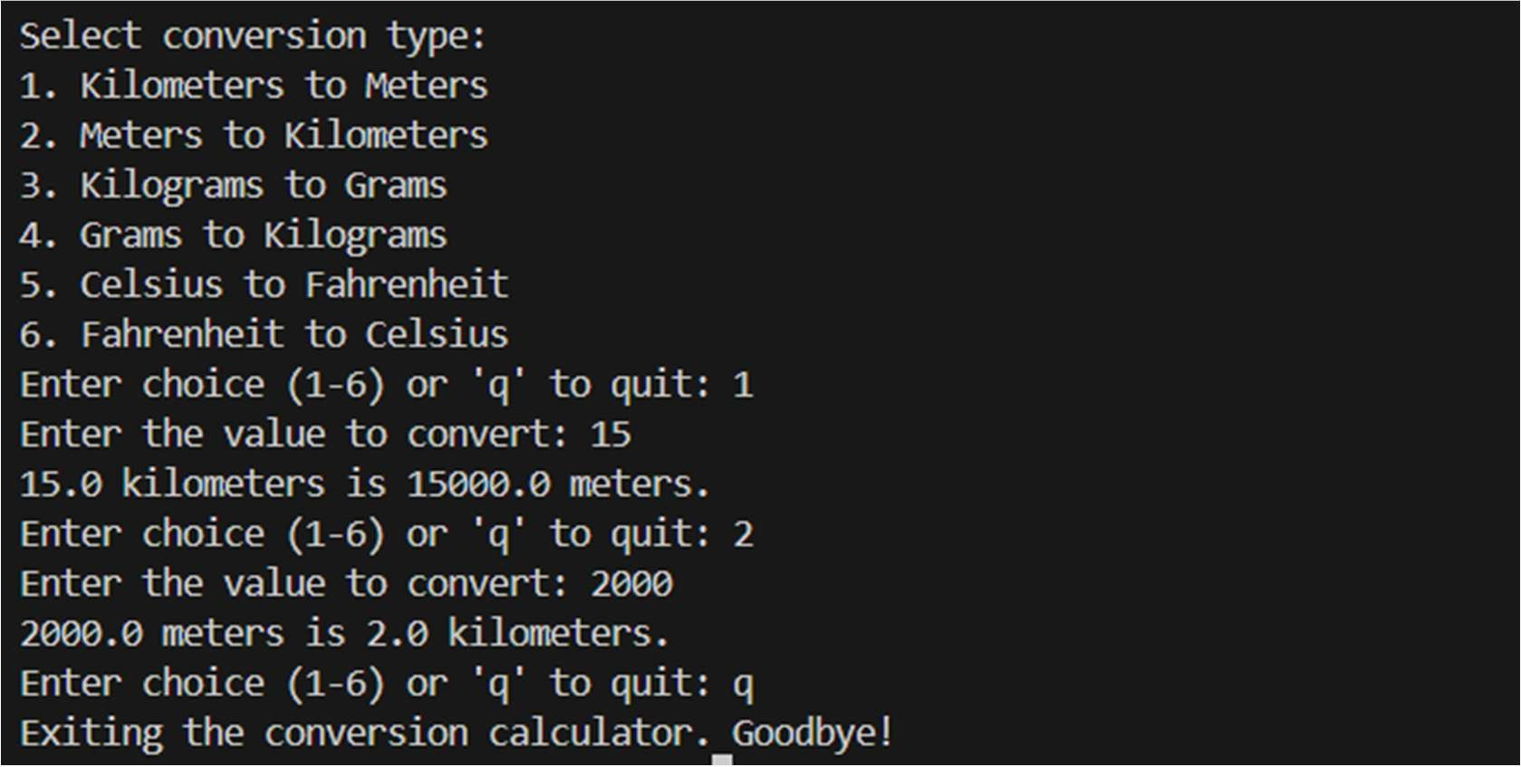

Explaination:

